Spring Concert, Part 1
Mandatory for: Beginning Band, Concert Band, and Handbells
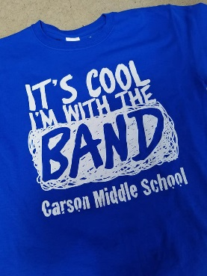
Tuesday, May 22, 2018 in the CMS Cafeteria

4:00 Call Time for Beginning Band; dress rehearsal
5:30 Call Time in the Cafeteria for Handbells and Concert Band
6:00 Concert Begins with groups in the following order: Handbells, 5th Grade Band, Beginning Band, Concert Band
7:00 Approximate end of concert. Please stay to support your fellow musicians in other ensembles.

Concert Outfits
Beginning Band and Concert Band: Blue CMS Band polo, black dress pants, black socks, black dress shoes
Handbells: Formal black and white attire (dress shoes required)

Tee Shirts will be on sale for $10 each.

Spring Concert, Part 1
Mandatory for: Beginning Band, Concert Band, and Handbells
Tuesday, May 22, 2018 in the CMS Cafeteria
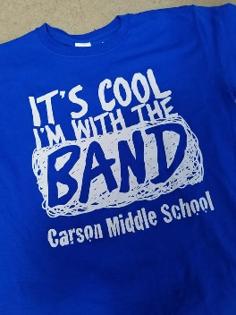
4:00 Call Time for Beginning Band; dress rehearsal
5:30 Call Time in the Cafeteria for Handbells and Concert Band
6:00 Concert Begins with groups in the following order: Handbells, 5th Grade Band, Beginning Band, Concert Band
7:00 Approximate end of concert. Please stay to support your fellow musicians in other ensembles.

Concert Outfits
Beginning Band and Concert Band: Blue CMS Band polo, black dress pants, black socks, black dress shoes
Handbells: Formal black and white attire (dress shoes required)

Tee Shirts will be on sale for $10 each.

